1. 
2. 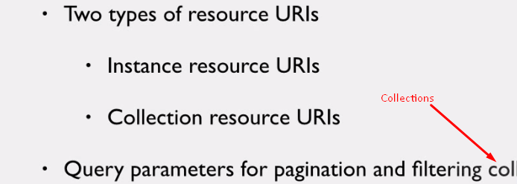
3. 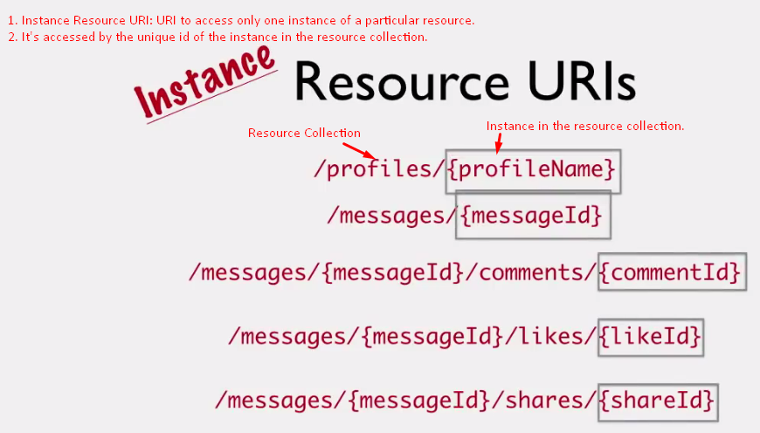
4. What if you want to access all messages?
5. 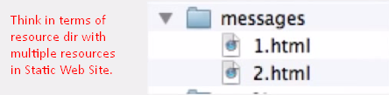
6. 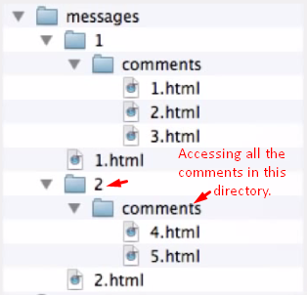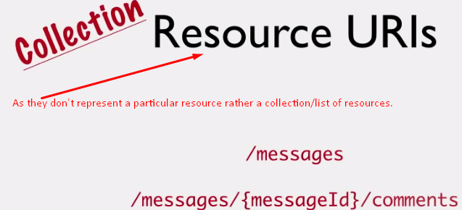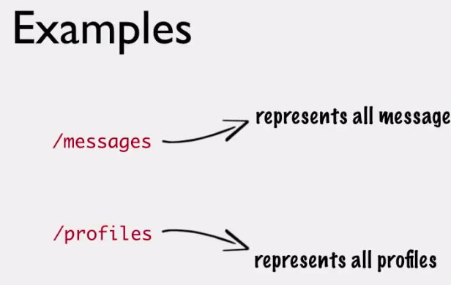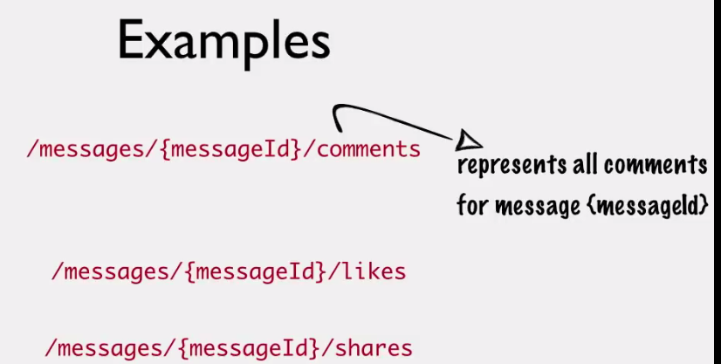
7. The above discussed collection Resource URIs also brings a problem.  
   What if you need a list of all comments irrespective of which message they are associated with?  
   As you have to provide a message id.  
    But now, it would give all the comments.   
   So, there is trade-off. You’ve to decide. Working one solution is not very common case.
8. Ok, when you have a collection URIs like this. Is there any way to filter the result?
9. : This would return a huge amount of data. But there must be a way for the client to filter or paginate.  
   Till now, we avoided the query parameters but for filtration and pagination, it’s a good scenario.
10. One best practice for pagination is via providing two query parameters. 